Spring Newsletter 2026
Year 3 - St Cecilia
Firstly, I would like to wish you all a Happy New Year! Many thanks for the lovely Christmas gifts and I hope that you and the children have had a good break over the holidays. During the forthcoming term the focus is on the quality and presentation of the children’s work in all subjects. As you are aware, we aim to develop thinking skills at St Mary’s to assist the children in their current and future learning. Regular reference is made during lessons to Edward De Bono’s Thinking Hats, Habits of Mind and Thinking Maps. Ask your child to tell you about which one/s they have used in class today!
This newsletter gives details on the areas of the curriculum to be covered during the spring term. PE sessions will be on Monday and Friday. As usual, hair needs to be tied back and no earrings should be worn on P.E. days. Please ensure that your child wears a complete P.E. kit in school which is the St Mary’s uniform and that they bring with them the correct size plimsolls or black trainers which they can change into before the lesson. Please continue to send in boxes of tissues so they are always available for the children to use in class. Many thanks to those of you who responded to this request in the autumn!
READING
Please try to read with your child for around 20 minutes each night, in order to develop fluency. Reading Records are provided so that the date, book and comments can be added by you or your child. Please encourage your child to fill in their Records regularly. We will continue to check Reading Records every Monday and expect to see that there have been at least 5 entries each week. Also, whenever you read with your child it will be of great benefit if you spend a little time discussing what they have read by encouraging them to think about the content of the text and asking them some questions. This is appropriate with both fiction and non-fiction texts and will greatly help to improve reading comprehension skills. During Guided Reading, children will answer questions linked to specific reading skills such as retrieving information, making inferences, explaining vocabulary and summarising the text. We have encouraged the children to use a dictionary to help learn the meaning and spelling of unknown words as they undertake their literacy homework. Please help support them in this.
HOMEWORK
Spellings, Handwriting, Mental Maths, Literacy and Numeracy homework will continue to be given every Wednesday, to be handed in on Monday. Please encourage your child to practise their times tables regularly as this knowledge is a great support to them in their Numeracy work.
Thank you for your continued support and we look forward to working with you and your child over the coming term.
Kind regards,
Miss Tanak
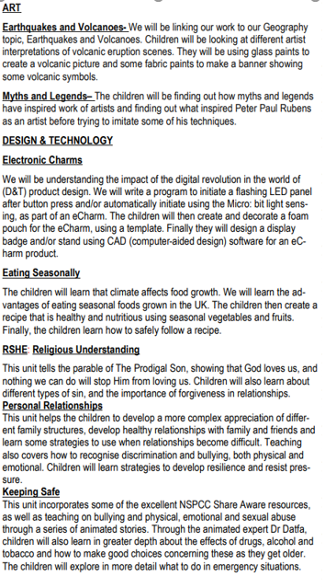
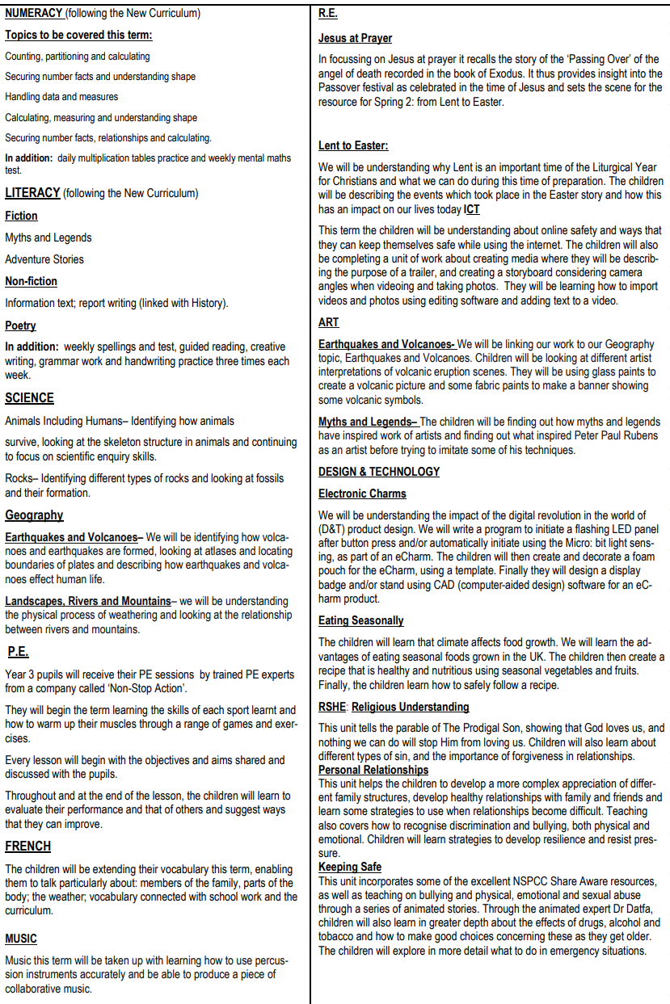
Galilee to Jerusalem
We will be exploring what Jesus meant by the Kingdom of God through Matthew’s Gospel. We will be understanding what Jesus’ miracles show us about God’s Kingdom and His compassion for people.
Desert to Garden
We will be understanding how Jesus showed his love at the Last Supper and how this love is shared when people celebrate the Eucharist. We will then begin to explore some different cultural practices associated with Holy Week.

