**LITERACY**

**Fiction-** Traditional tales from European countries (guided reading)

**Non-Fiction-** Information text, Non chronological report writing,

Explanation text, Newspaper report, Instructional text, Diary entry

Letter writing

**ICT**

Use the internet to carry out various research tasks.

Use interactive maps to find out about the location of different places, rivers and mountains in Europe

Use word processing skills to produce a final draft of a fact file, a newspaper article or a report.

**GEOGRAPHY**

To use an atlas, globes and maps to locate and identify countries in Europe.

To use geographical vocabulary to describe physical features of European countries.

To use an atlas and maps to locate the main rivers and mountains, investigate about their routes and locations.

To understand the concept of trade and recognise the different kind of trade.

To be able to identify different resources that can be traded.

To describe what resources are import and export

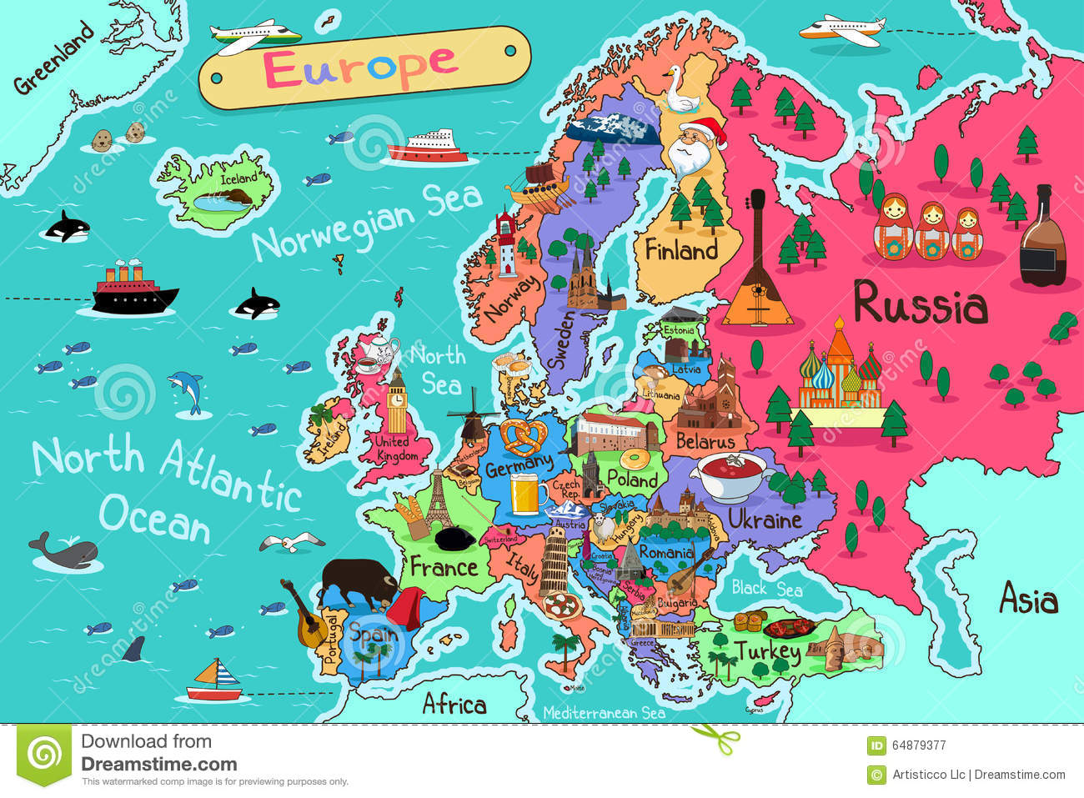

**MATHS**

Multiplication and division to find out amounts of resources that have been exported.

Measures to find out length, weights, perimeter and areas of different places.

**ART**

To learn about the different styles of cityscape and different artists that produce this type of art.

To understand what inspired Camille Pissarro as an artist.