Autumn Term 2025-2026
Year 5
St Joseph & St Anthony
Miss Cefla Chafla & Mr Dixon
History
Literacy

- The children will be making comparisons between the ancient Mayan land in Mexico and modern maps.
- The children will be identifying the physical features of Mexico and its surrounding areas.
- The children will write diary entries based on the life of Mayan people.
- They will structure newspaper articles based on the changes of the Mayan Civilisation.
- They will read, understand and interpret Mayan myths and folk stories as well as information books on the Mayans.

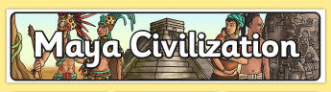
- During the Enfield Sings project, we will be learning to sing and perform songs about the Mayans/ Aztecs. Using body percussion to create a piece.
Geography
- The children will place the Mayan Civilization on a timeline.
- The class will be researching the life of the Mayan people.
- They will be studying the way that the Mayans worshipped.
- The role of the gods and goddesses in the Mayan times will be researched.
Music
D&T
Art
- The children will be using the internet to research different aspects of Mayan life.
ICT
- The children will be designing and making their own Mayan masks based on Maya art and fashion.
- The children will be looking closely at Mayan pots, gods, architecture and artefacts.

